**Part A: Background**

**Please read the Part A and answer this below question**

**An IP design (IPv4 only) that meets the needs of their new office and business.**

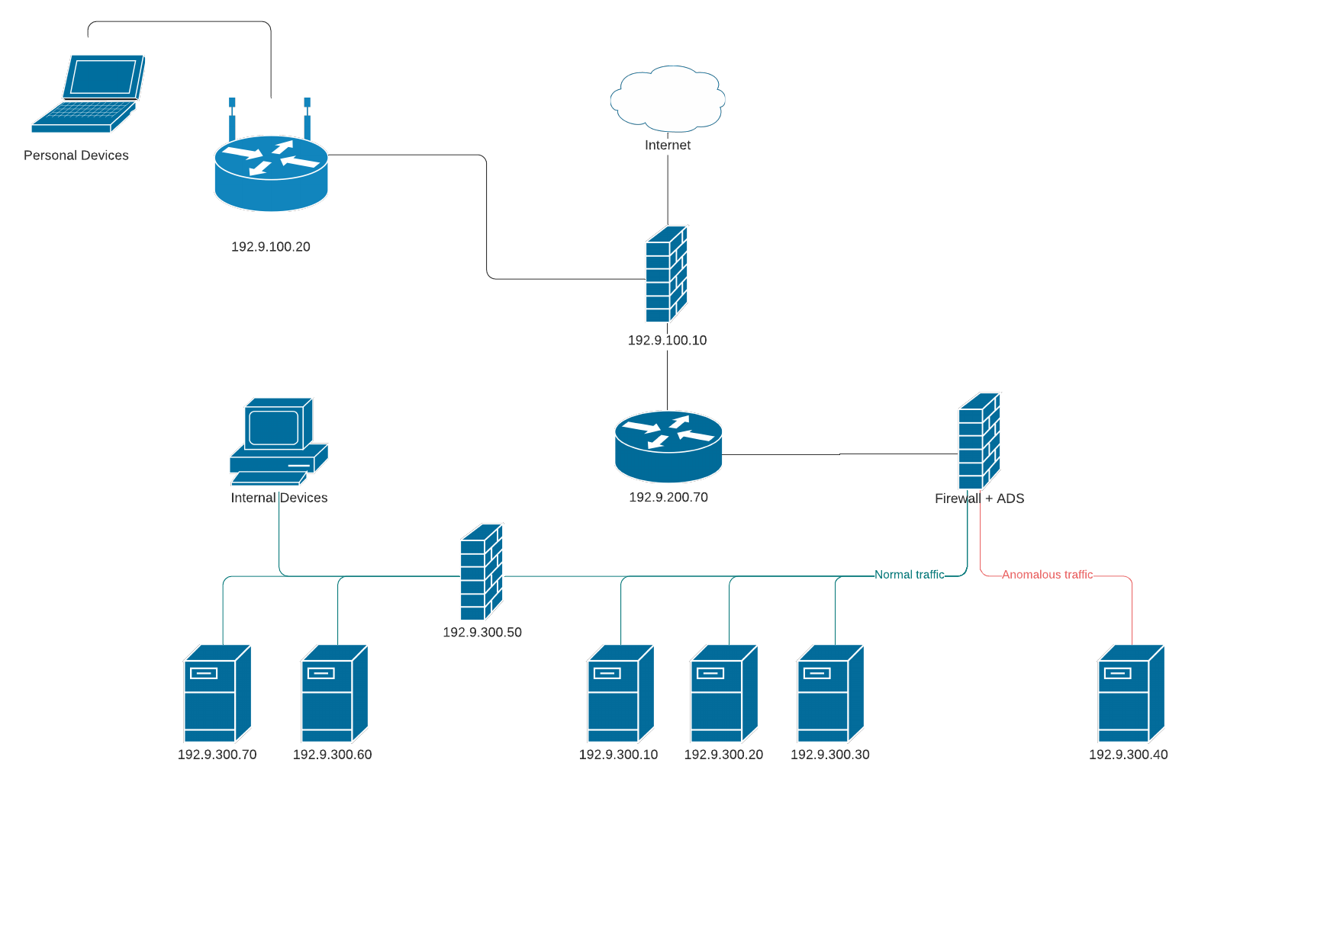

**Answer here:**

**Using Packet Tracer, build the PC – Switch – Router - PC topology. Cable the topology using the appropriate cables and demonstrating a console cabling for both PCs. You must identify the types of cabling you have used.**

**Answer here:**

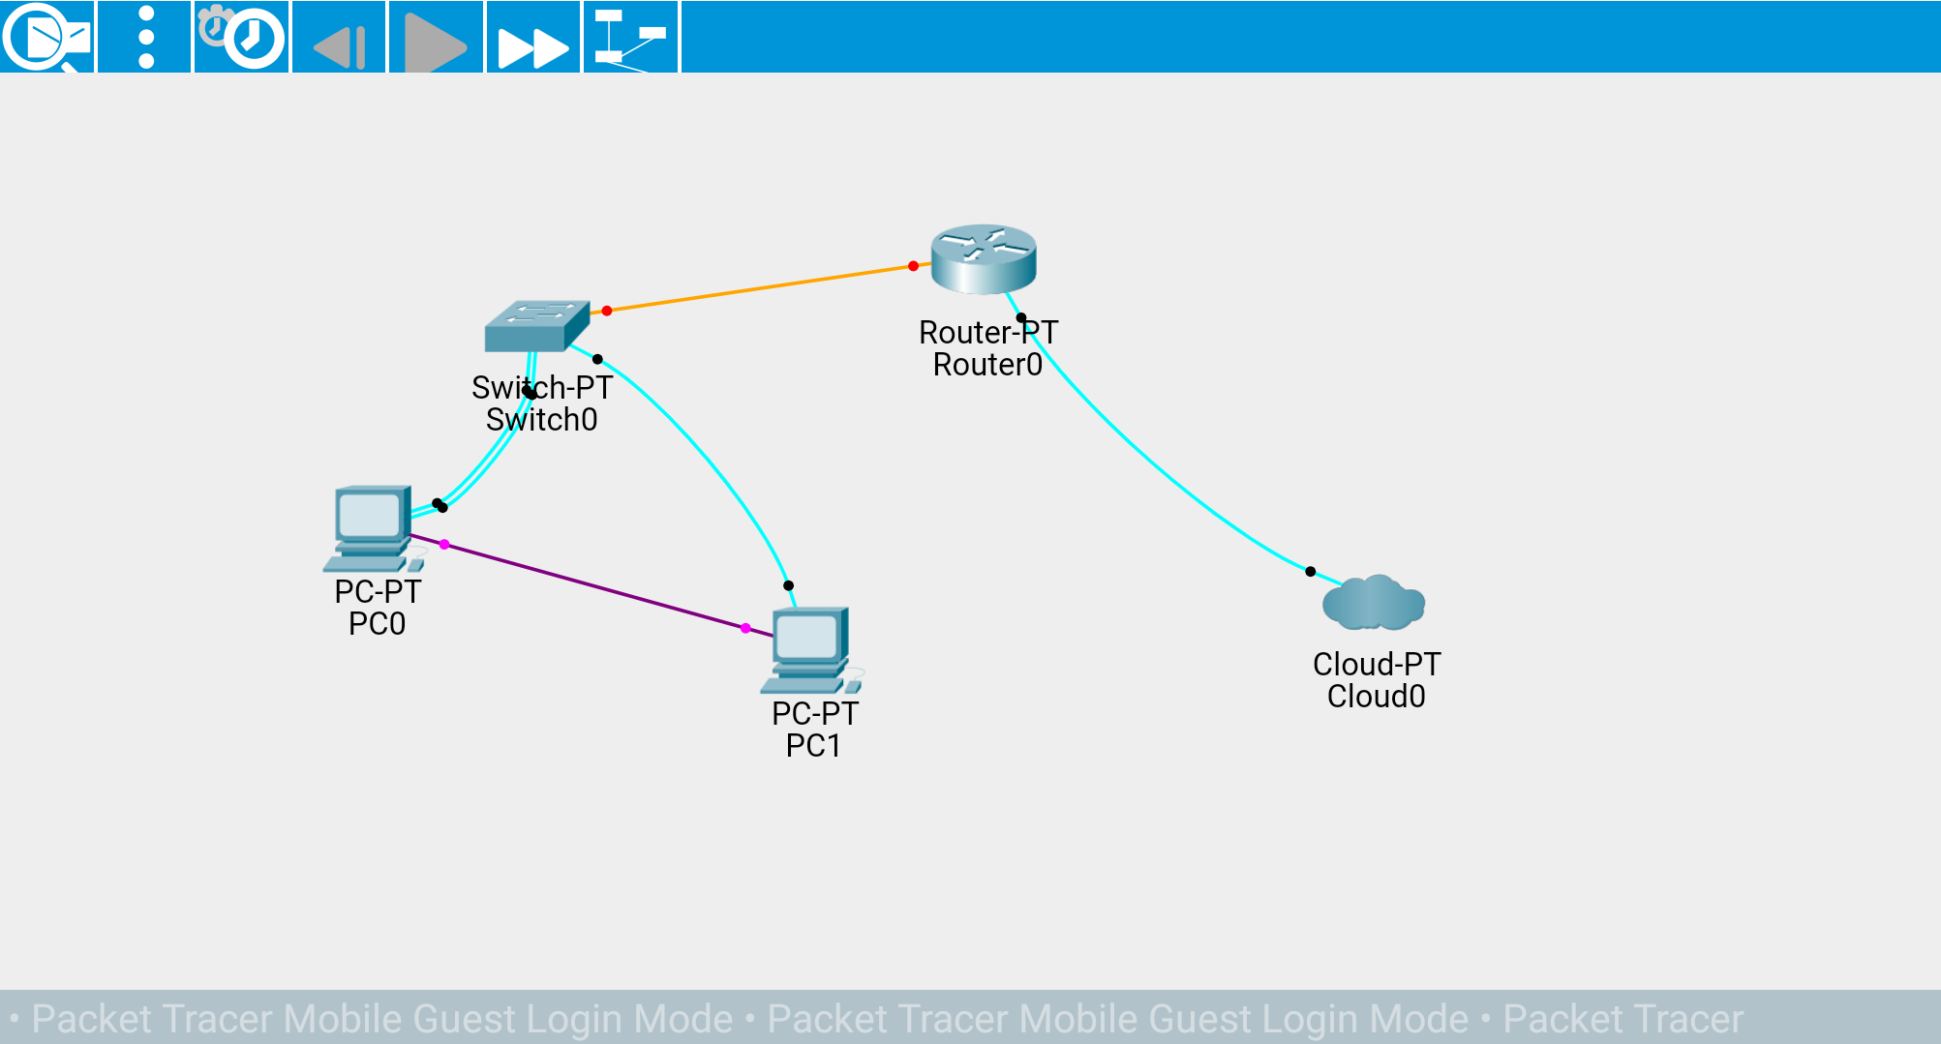

The 2 computers are connected using a usb cable with the port being used usb1. Both pc’s are connected to the switch using a console cable with both the switch and the pcs using console port for the connection. The switch is connected to the router using a fibre cable using FE4/0 port. The router is connected to the cloud using a console cable.

**NIST incident response standards details implementation Tiers, as follows:**

**Provide a brief description of each.**

**Answer here:**

**1. Partial Implementation- Cyber security is carried out in a reactive manner ie it is done if and when the cuber-security incidence happens. The lack of clear guidelines to handle cuber-security incidences makes tier 1 companies hard to handle and mitigate cuber-security incidences.**

**2. Risk Informed – Risc management practices are approved by management but are not implemented as organisation wide practices. Even though the awareness of cuber-security risk exists in the company, it is not standardised and is shared informally.**

**3. Repeatable- These organisations have formally approved risk management strategies and policies. In this tier senior Cyber security and management executives constantly communicate about the state of the company Cybersecurity risk**

**4. Adaptive- These organisations adapt their Cybersecurity practices based on previous and current Cybersecurity activities, including lessons learned and predictive factors.**

**An ICT technician sends a piece of harmless malware in the form of an email attachment to all employees within the company.**

**The email attachment is titled ‘HR Payroll Instructions ‘**

**Discuss the purpose of this exercise.**

**Answer here:**

Email viruses cause the majority of the computer viruses that attack organisations in the world. The code can be activated by downloading the attachment or interacting with the body of the email in any way. This exercise is carried with a goal to make the employees aware of how malware can be transmitted and infect computers. By the end of it, employees should also learn how to spot suspicious emails and know the correct way to deal with Cyber security events when they occur.